Ashcon Abae

Signals and Systems

October 15, 2019

Homework #2

1. Q1.27 (a,f)
   * 1. The **Linear (3)** and **Stable (5)** properties hold for this Continuous-Time System. To determine this:

First, we consider the output at t=0: $$y\left(0\right)=x\left(-2\right)+x(2)$$ 
The output y(0) is dependent upon the past value, x(-2), and the future value, x(2). Therefore, by definition, this system cannot be **Causal** and it has **Memory**.

Next, we consider a shift t0 in the output y(t):  
If the input is shifted to t0 and passed through the system, then the output is:  
From this, it is clear that a shift of t0 in the output doesn’t have a corresponding shift in the input. Therefore, this system is **Time-Variant**.

Then, we apply the superposition principle to verify the linearity of the system. Let’s consider: $$y_{1}\left(t\right)=x_{1}\left(t-2\right)+x_{1}\left(2-t\right) \\ y_{2}\left(t\right)=x_{2}\left(t-2\right)+x_{2}\left(2-t\right)$$ 
We then consider a third input x3(t) such that x3(t) is a linear combination of x1(t) and x2(t):  
Thus, the output y3(t) is given as: $$y_{3}\left(t\right)=x_{3}\left(t-2\right)+x_{3}\left(2-t\right) \\ y_{3}\left(t\right)=ax_{1}\left(t-2\right)+bx_{2}\left(t-2\right)+ax_{1}\left(2-t\right)+bx_{2}\left(2-t\right) \\ y_{3}\left(t\right)=ax_{1}\left(t-2\right)+ax_{1}\left(2-t\right)+bx_{2}\left(t-2\right)+bx_{2}\left(2-t\right) \\ y_{3}\left(t\right)=a\left[x_{1}\left(t-2\right)+x_{1}\left(2-t\right)\right]+b\left[x_{2}\left(t-2\right)+x_{2}\left(2-t\right)\right] \\ y_{3}\left(t\right)=ay_{1}\left(t\right)+by_{2}(t)$$ 
From this, it is clear that this system satisfies both Additivity and Homogeneity properties, therefore this system is **Linear**.

Finally, let’s consider $\left|x\left(t\right)\right|<∞$ for all t, then: $$\left|y\left(t\right)\right|=\left|x\left(t-2\right)+x\left(2-t\right)\right| \\ \left|y\left(t\right)\right|≤\left|x\left(t-2\right)\right|+\left|x\left(2-t\right)\right| \left(∵\left|a+b\right|≤\left|a\right|+\left|b\right|\right) \\ \left|y(t)\right|<∞ \left(∵\left|x(t)\right|<∞\right)$$ 
From this, it is clear that this system is **Stable**.

$y\left(t\right)=x\left(\frac{t}{3}\right)$

1. The **Linear (3)** and **Stable (5)** properties hold for this Continuous-Time System. To determine this:  
   First, we consider the output at t=0: $$y\left(0\right)=x\left(\frac{0}{3}\right)=x\left(0\right)$$ 
   The output, y(3) at t=3, is dependent upon the past value, x(1). The output, y(-3) at t=-3, is dependent upon the future value, x(-1). Therefore, by definition, this system cannot be **Causal** and has **Memory**.  
     
   Next, we consider a shift t0 in the output y(t):  
   If the input is shifted to t0 and passed through the system, then the output is  
   From this, it is clear that a shift of t0 in the output does not have a corresponding shift in the input, which implies that the system is **Time-variant**.  
     
   Then, we apply the superposition principle to verify the linearity of the system. Let’s consider: $$y_{1}\left(t\right)=x_{1}\left(\frac{t}{3}\right) \\ y_{2}\left(t\right)=x_{2}\left(\frac{t}{3}\right)$$ 
   Let’s now consider a third input x3(t) such that x3(t) is a linear combination of x1(t) and x2(t):  
   Thus, the output y3(t) would be given as: $$y_{3}\left(t\right)=x_{3}\left(\frac{t}{3}\right) \\ y_{3}\left(t\right)=ax_{1}\left(\frac{t}{3}\right)+bx_{2}\left(\frac{t}{3}\right) \\ y_{3}\left(t\right)=ay_{1}\left(t\right)+by_{2}(t)$$ 
   From this, it is clear that this system satisfies both Additivity and Homogeneity properties. Therefore, this system is **Linear**.  
     
   Finally, let’s consider $\left|x(t)\right|<∞$ for all t, then: $$\left|y(t)\right|=\left|x\left(\frac{t}{3}\right)\right|$$ 
   As $\left|x(t)\right|<∞$, the time scaled version of x(t) will only spread the signal over time, but it is still stable. Therefore, this system is **Stable**.
2. Q1.31
   1. 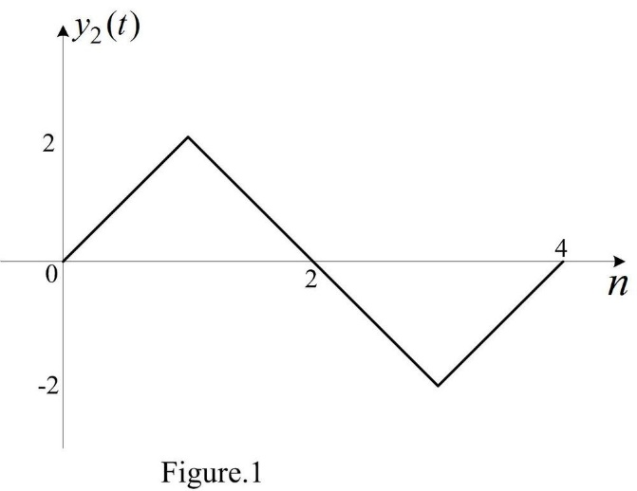Given a Linear Time-Invariant (LTI) system whose response to an input signal x1(t) is y1(t). That is, . From the input x2(t) depicted in P1.31c, the signal x2(t) can be written in terms of x1(t):  
      Because x1(t) is linear and time-invariant, the output y2(t) of signal x2(t) is:  
      Thus, the signal y2(t) can be depicted below:
   2. 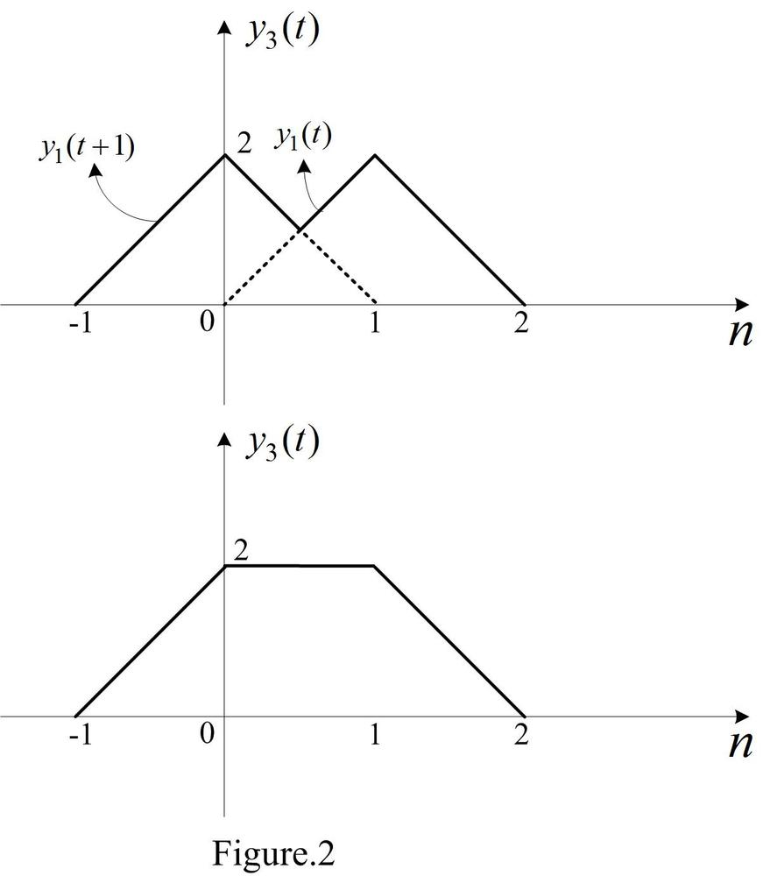From the input x3(t) depicted in P1.31d, the signal x3(t) can be written in terms of x1(t):  
      Because x2(t) is linear and time-invariant, the output y3(t) of signal x3(t) is:  
      Thus, the signal y3(t) can be depicted below:
3. 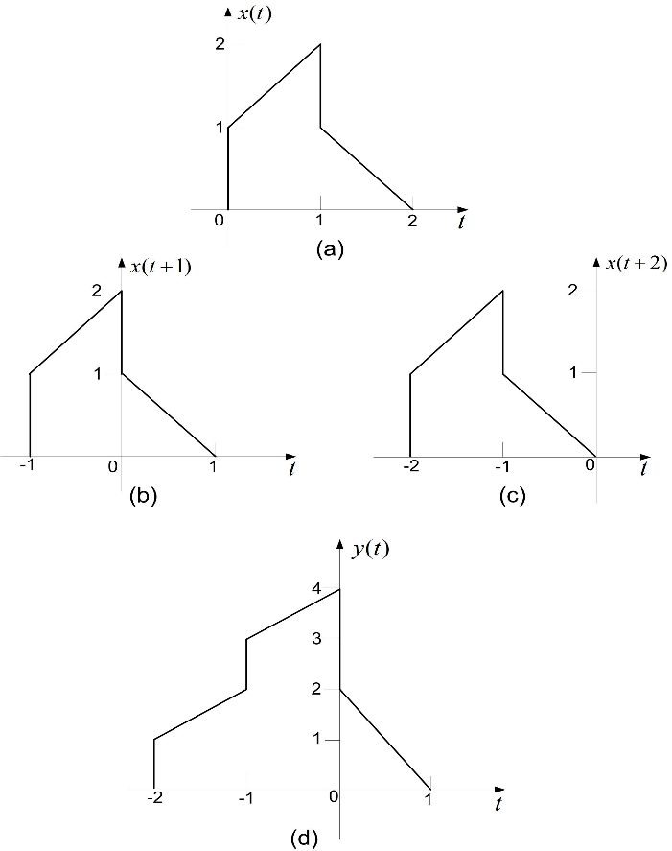Q2.8
   1. $x\left(t\right)=\left\{\begin{aligned}t+1, 0≤t≤1 \\ 2-t, 1<t≤2 \\ 0, otherwise\end{aligned}\right. h\left(t\right)=δ\left(t+2\right)+2δ\left(t+1\right)$ Given this information, we can determine y(t) using the convolution y(t)=x(t)*h(t): $$y\left(t\right)=\int_{-∞}^{∞}{x\left(τ\right)h\left(t-τ\right)dτ}=\int_{-∞}^{∞}{x\left(τ\right)\left\{δ\left(t-τ+2\right)+2δ\left(t-τ+1\right)\right\}dτ} \\ y\left(t\right)=\int_{-∞}^{∞}{x\left(τ\right)δ\left(t+2-τ\right)dτ}+2\int_{-∞}^{∞}{x\left(τ\right)δ\left(t+1-τ\right)dτ} \\ y\left(t\right)=x\left(t+2\right)+2x(t+1)$$ 
      Now, let’s consider x(t+2): $$x\left(t+2\right)=\left\{\begin{aligned}t+3, -2≤t≤-1 \\ -t, -1<t≤0 \\ 0, otherwise\end{aligned}\right.$$ 
      Similarly, let’s consider x(t+1): $$x\left(t+1\right)=\left\{\begin{aligned}t+2, -1≤t≤0 \\ 1-t, 0<t≤1 \\ 0, otherwise\end{aligned}\right.$$ 
      Therefore, $y\left(t\right)=x\left(t+2\right)+2x(t+1)$ is given as: $$y\left(t\right)=\left\{\begin{aligned}\begin{aligned}t+3, -2≤t≤-1 \\ t+4, -1<t≤0 \\ 2-2t, 0<t≤1\end{aligned} \\ 0, otherwise\end{aligned}\right.$$ 
      x(t) is plotted below in graph (a). x(t+2) and x(t+1) are plotted below in graphs (b) and (c) respectively. The convolution y(t) is plotted below in graph (d):
4. Q2.11
   1. Given: $$x\left(t\right)=u\left(t-3\right)-u\left(t-5\right)=\left\{\begin{aligned}1, 3≤t<5 \\ 0, otherwise\end{aligned}\right. \\ h\left(t\right)=e^{-3t}u\left(t\right)$$ 
      The convolution is given by: $$y\left(t\right)=x\left(t\right)*h\left(t\right)=\int_{-∞}^{∞}{x\left(τ\right)h\left(t-τ\right)dτ}=\int_{-∞}^{∞}{x\left(t-τ\right)h\left(τ\right)dτ}$$ 
      We then plot x(t), h(t), x(t-𝜏), h(𝜏) below in graphs (a), (b), (c), and (d) respectively:  
      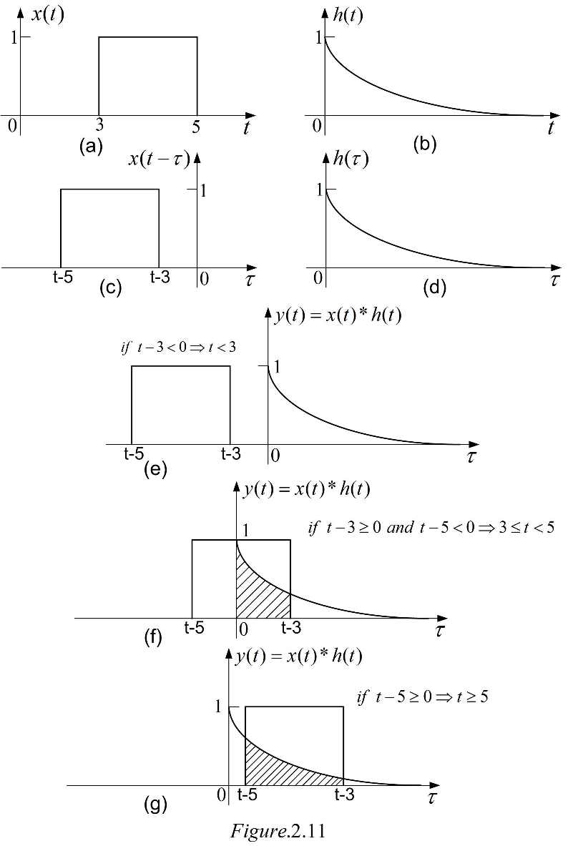  
      For t-3<0, y(t)=0. That is $y\left(t\right)=0, if t<3$.For t-3≥0 & t-5<0: $$y\left(t\right)=\int_{0}^{t-3}{\left(1\right)e^{-3τ}dτ} \\ y\left(t\right)={\left.-\frac{1}{3}e^{-3τ}\right|}_{0}^{t-3} ;3≤t<5 \\ y\left(t\right)=\frac{1-e^{-3\left(t-3\right)}}{3}, if 3≤t<5$$ 
      For t-5≥0: $$y\left(t\right)=\int_{t-5}^{t-3}{\left(1\right)e^{-3τ}dτ} \\ y\left(t\right)={\left.-\frac{1}{3}e^{-3τ}\right|}_{t-5}^{t-3} ;t≥5 \\ y\left(t\right)=\frac{1}{3}\left(e^{-3\left(t-5\right)}-e^{-3\left(t-3\right)}\right) ;t≥5 \\ y\left(t\right)=\frac{\left(1-e^{-6}\right)e^{-3(t-5)}}{3}, if t≥5$$ That is, convolution y(t) is as follows: $$y\left(t\right)=\left\{\begin{aligned}0, if-∞<t<3 \\ \frac{1-e^{-3\left(t-3\right)}}{3}, if 3≤t<5 \\ \frac{\left(1-e^{-6}\right)e^{-3(t-5)}}{3}, if t≥5\end{aligned}\right.$$
   2. To compute g(t), we first consider $\frac{dx\left(t\right)}{dt}$: $$\frac{dx\left(t\right)}{dt}=\frac{d}{dt}\left\{u\left(t-3\right)-u\left(t-5\right)\right\}=δ\left(t-3\right)-δ\left(t-5\right)$$ 
      This signal, $\frac{dx\left(t\right)}{dt}$, is plotted below:  
      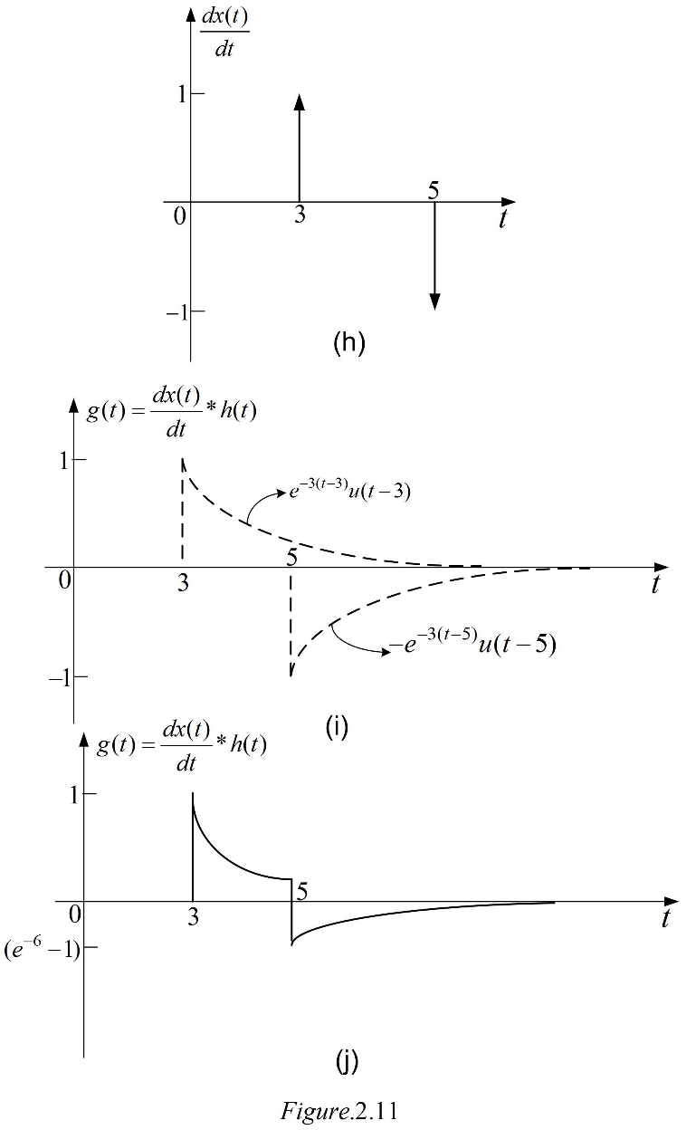  
      Next, we plug back into g(t): $$g\left(t\right)=\left(δ\left(t-3\right)h\left(t\right)\right)-\left(δ\left(t-5\right)h\left(t\right)\right) \\ g\left(t\right)=h\left(t-3\right)-h\left(t-5\right) \\ g\left(t\right)=\left(e^{-3\left(t-3\right)}u(t-3)\right)-\left(e^{-3\left(t-5\right)}u(t-5)\right)$$ 
      Therefore, we can write g(t) as: $$g\left(t\right)=\left\{\begin{aligned}0, -∞<t<3 \\ e^{-3(t-3)}, 3≤t<5 \\ \left(e^{-6}-1\right)e^{-3(t-5)}, t≥5\end{aligned}\right.$$
   3. We can see that y(t) calculated in part (a) is related to g(t) calculated in part b as: $$g\left(t\right)=\frac{dy(t)}{dt}=\left(\frac{dx\left(t\right)}{dt}\right)h(t)$$
5. Q2.19 (a)
   1. Given S1 is Causal LTI with output response:  
      and S2 is Causal LTI with output response: $$y\left[n\right]=αy\left[n-1\right]+Βw[n]$$ 
      Let’s rewrite: $$w\left[n\right]=\frac{1}{β}y\left[n\right]-\frac{α}{β}y[n-1]$$ 
      Next: $$w\left[n-1\right]=\frac{1}{β}y\left[n-1\right]-\frac{α}{β}y[n-2]$$ 
      Substituting, we get: $$w\left[n\right]-\frac{1}{2}w\left[n-1\right]=\frac{1}{β}y\left[n\right]-\frac{α}{β}y\left[n-1\right]-\frac{1}{2β}y\left[n-1\right]-\frac{α}{2β}y\left[n-2\right]=x[n] \\ y\left[n\right]=\left(α+\frac{1}{2}\right)y\left[n-1\right]-\left(\frac{α}{2}\right)y\left[n-2\right]+βx[n] \\ y\left[n\right]=-\frac{1}{8}y\left[n-2\right]+\frac{3}{4}y\left[n-1\right]+x[n]$$ 
      On comparing the above 2 equations, we solve for α and β: $$α=\frac{1}{4}, β=1$$